**PROJECT EXECUTION PROCEDURE**

**-----------------------------------------------**

----> WITH OUT USING MYECLIPSE (USING SYSTEM TOMCAT SERVER)

---> USING MYECLIPSE

**EXECUTION STEPS:**

----------------

I.BACKEND (DATABASE CREATION, DUMP FILE IMPORTING)

II.FRONTEND (CODE DEPLOYMENT IN SERVER)

III.CONNECTIVITY (FRONTEND TO BACKEND CONNECTIVITY)

IV.HOW TO RUN PROJECT

**I.BACKEND:**

**==========**

(BACKEND IS SAME FOR BOTH PROCEDURES)

1. Go to start-->run--->sqlplus.exe (sqlplus.exe window)

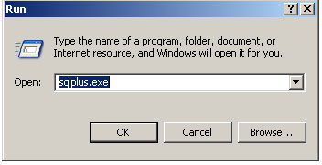

2. Login as administrator (enter admin username/password)

3. Create new user account from admin account

sql> create user <USERNAME> identified by <PASSWORD>;

user created.

sql> grant dba to <USERNAME>;

Grant Suc cessed.

4.connect newly created user.

sql> connect username/password;

5.verify user is connected or not.

sql>show user;

user is "USERNAME"

6. check is there any data tables in this user.

sql>select * from tab;

no rows selected

(display list of tables with count).

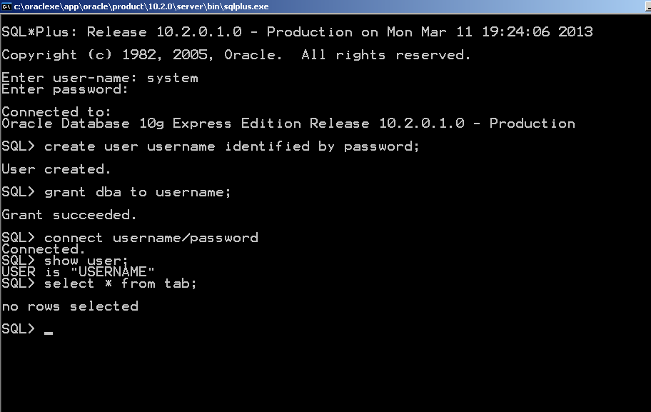

7.Import project database dump file into created user.

start->run->imp.exe(window)

imp.exe window

--------------

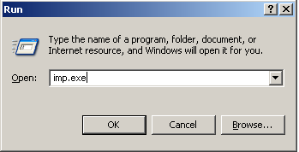

enter username/password;

Import file: EXPDAT.DMP >c:\abcd\efg\dump.dmp(path is for only example.

you have to give system dump file available path)

(select file drag and drop on the imp.exe window its very easy).

Import file: EXPDAT.DMP >"c:\abcd\efg\dump.dmp" ( some case having double quotation then remove double qoutations)

Enter insert buffer size (minimum is 8192) 30720>(NO NEED BUFFERSIZE PRESS ENTER)

List contents of import file only (yes/no): no > no

->PRESS Enter

Ignore create error due to object existence (yes/no): > yes

->PRESS Enter

Import grants (yes/no): > yes

->PRESS Enter

Import table data (yes/no): > yes

->PRESS Enter

Import entire export file (yes/no): > yes

->PRESS Enter

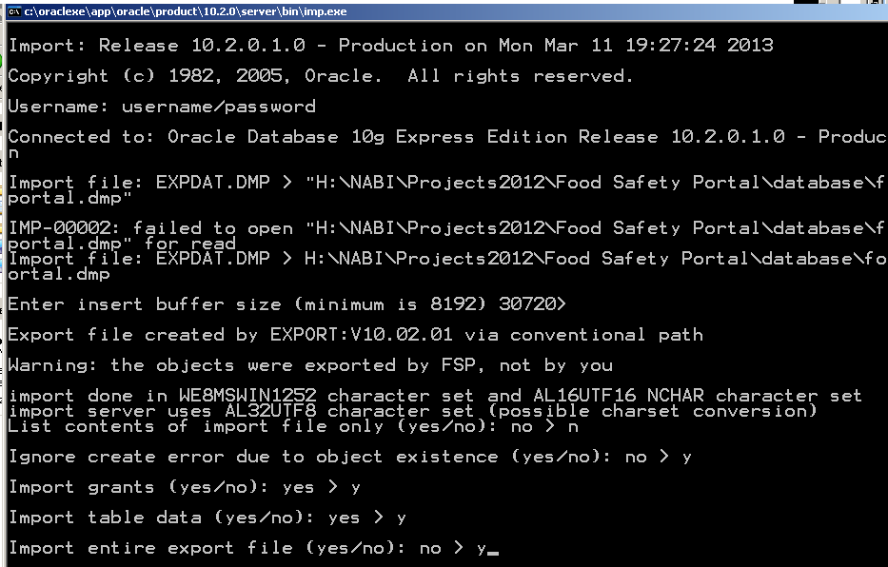

(Import procedure done automatically after that window automatically closed)

8. GO TO BACK SQLPLUS.EXE WINDOW

SQL>SELECT * FROM TAB;

(list of data table with count)

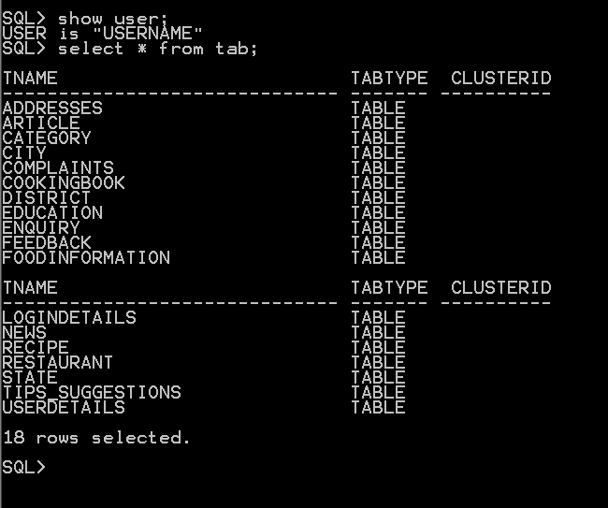

9.IF YOU WANT TO SEE THE DATA TABLE AND DATA OF THE TABLE

SQL>DESC <TABLENAME>;

(it gives list of column names and datatypes)

SQL>SELECT * FROM <TABLENAME>;

SQL>SEELCT COLNAME1,COLNAME2,COLNAME3... FROM <TABLNAME>;

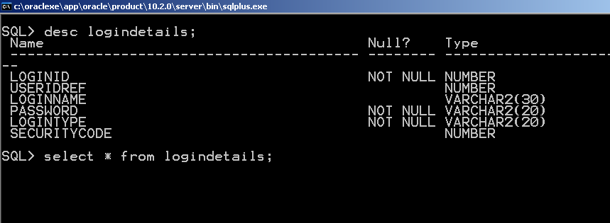

========================================================================

WITH OUT USING MYECLIPSE:

==========================

II.FRONTEND(CODE DEPLOYMENT):

============================

1. COPY TOMCAT CODE FROM YOUR PROJECT CODE

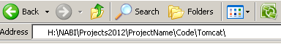

2. PASTE COPIED CODE INTO TOMCAT WEBAPP FOLDER.

TOMCAT 6.0/WEBAPPS/(PASTE)PROJECTFOLDER



COPY PROJECT JARS FROM STRUTS JAR FOLDER AND PASTED IT INTO proectname/WEB_INF/lib/



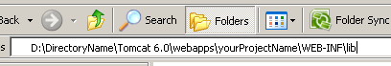

III.CONNECTIVITY:

================

1. OPEN TOMCAT/WEBAPPS/PROJECTFOLDER(PASTED FOLDER)/WEB-INF/CLASSES/hibernate.cfg.xml

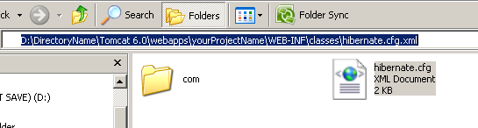

This file having database connectivity details

OBSERVE:

-------

<property name="connection.url">jdbc:oracle:thin:@DB-SYSTEM-HOSTNAME:PORTNUMBER:SERVICENAME</property>

<property name="connection.username">PROJECT-DB-USERNAME</property>

<property name="connection.password">PROJECT-DB-PASSWORD</property>

URL: DB-SYSTEM-HOSTNAME:PORTNUMBER:SERVICENAME

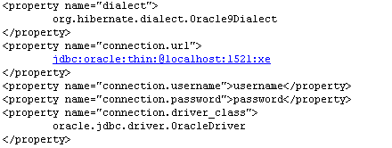

have to be change system to system;

HOSTNAME,PORTNUMBER,SERVICENAME available in

TNSNAMES.ORA file in ORACLE installed folder.

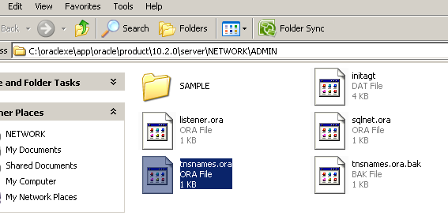

(search file tnsnames.ora in oracle folder).

change url according to database system tnsnames.ora file.

PROJECT-DB-USERNAME:change project database username.

PROJECT-DB-PASSWORD:change project database password.

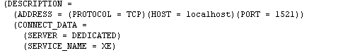

SAVE and CLOSE the HIBERNATE.CFG.XML file

**IV. HOW TO START PROJECT:**

**=========================**

1. START TOMCAT SERVER

TOMCAT\BIN\Tomcat.EXE (RUN)

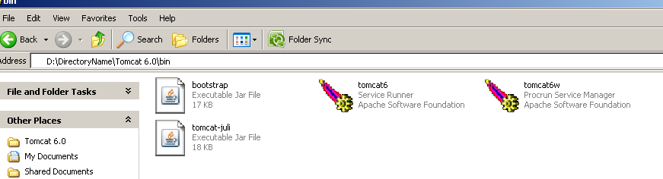

INFO: Server startup in 798 ms

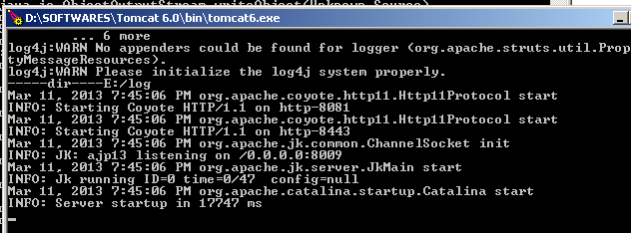

2. OBSERVE SERVER PORT NUMBER

INFO: Starting Coyote HTTP/1.1 on http-8081

PORT NUMBER: 8081(IT MAY BE DIFFERENT ONE.

IT IS GIVEN AT THE TIME OF INSTALATION)

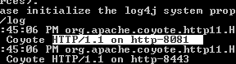

3.OPEN BROWSER(ANY BROWSER).

4.TYPE URL IN ADDRESS BAR:

http://localhost:8081/Projectname(case sensitive)

(or)

http://systemname:/8081/Projectname

(or)

http://ipaddress:/8081/Projectname

**EXECUTION PROCEDURE IN MYCELIPSE:**

**=================================**

CODE IMPORT PROCEDURE IN MYECLIPSE:

-----------------------------------

MYECLIPSE-->FILE->IMPORT

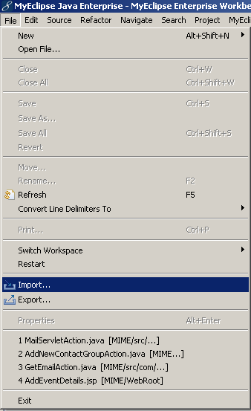

->GENERAL->EXISTING PROJECTS->NEXT

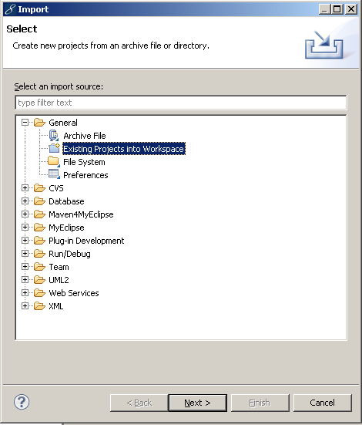

->BROWSE->SELECT->SYSTEM MYECLIPSE CODE PATH

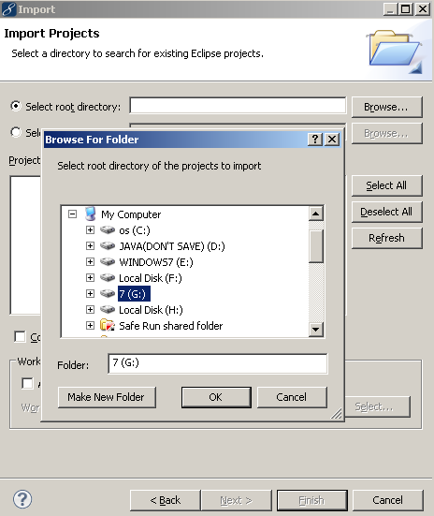

->SELECT ALL(click)->FINISH.

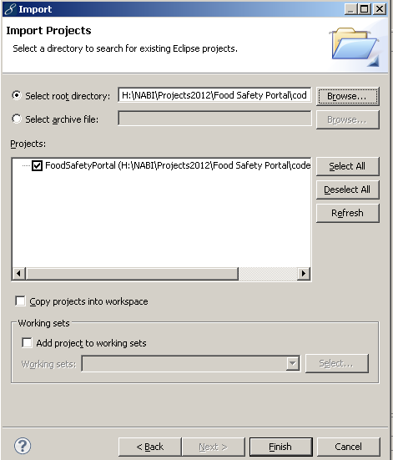

**CONFIGURE CLASSPATH FOR JARS (IF YOU HAVE JAR FILES ERRORS):**

**----------------------------**

RIGHT CLICK ON PROJECTNAME->BUILDPATH->CONFIGUREBUILD PATH

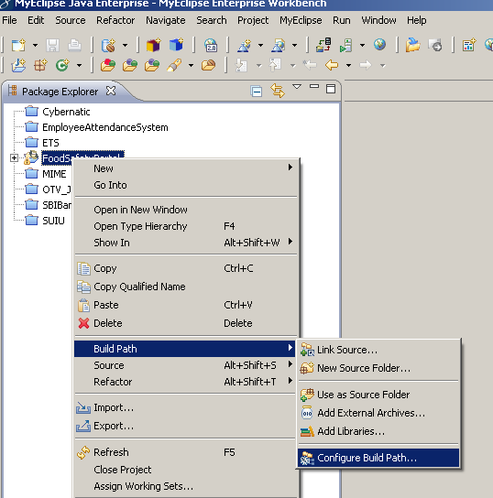

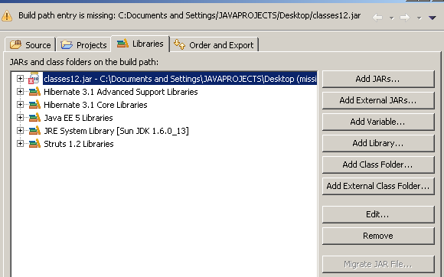

->LIBRARIES(SELECT)

->SELECT ERROR JARs AND DUPLICATE JARS REMOVE->REMOVE(CLICK)

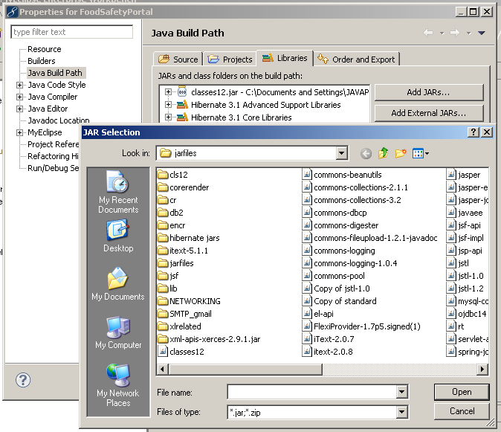

->ADD REMOVED JAR FILES FROM PROJECT FOLDER.

CONNECTIVITY IN MYECLIPSE:

--------------------------

1.OPEN PROJECT(IN PACKAGE EXPLORER)/SRC/HIBERNATE.CFG.XML

This file having database connectivity details

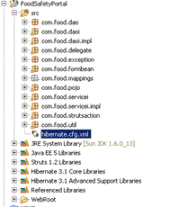

<property name="connection.url">jdbc:oracle:thin:@DB-SYSTEM-HOSTNAME:PORTNUMBER:SERVICENAME</property>

<property name="connection.username">PROJECT-DB-USERNAME</property>

<property name="connection.password">PROJECT-DB-PASSWORD</property>

URL: DB-SYSTEM-HOSTNAME:PORTNUMBER:SERVICENAME

have to be change system to system;

HOSTNAME,PORTNUMBER,SERVICENAME available in

TNSNAMES.ORA file in ORACLE installed folder.

(search file tnsnames.ora in oracle folder).

change url according to database system tnsnames.ora file.

PROJECT-DB-USERNAME:change project database username.

PROJECT-DB-PASSWORD:change project database password.

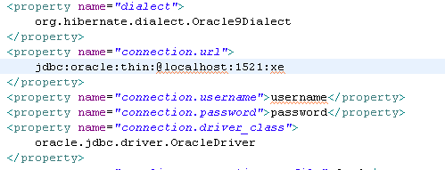

SAVE and CLOSE the HIBERNATE.CFG.XML file

HOW TO RUN PROJECT:

-------------------

1) RIGHT CLICK ON PROJECT---->RUN AS-->MYECLIPSE SERVER APPLICATION.

(AUTOMATICALLY SERVER WILL RUN AND MYECLIPSE BROWSER ALSO OPENED)

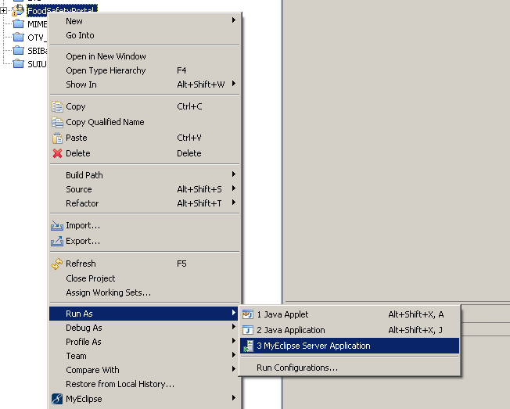

EXECUTION PROCEDURE END.

HOW TO CREATE DATABASE DUMP FILE:

=================================

start->run->exp.exe(window)

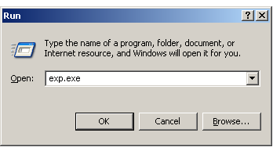

Enter username and password which user data to be exported.

USERNAME:XXXXX

PASSWORD:YYYYY

ENTER BUFFERSIZE :> NOT NECESSARY PRESS ENTER

Export file: EXPDAT.DMP >c:\XXX.dmp(where to be created file path).

(1)E(ntire database), (2)U(sers), or (3)T(ables): (2)U > u

Export grants (yes/no): yes > y

Export table data (yes/no): yes > y

Compress extents (yes/no): yes > y

About to export specified users ...

User to be exported: (RETURN to quit) > hcss(which user data to exported)

User to be exported: (RETURN to quit) > PRESS ENTER

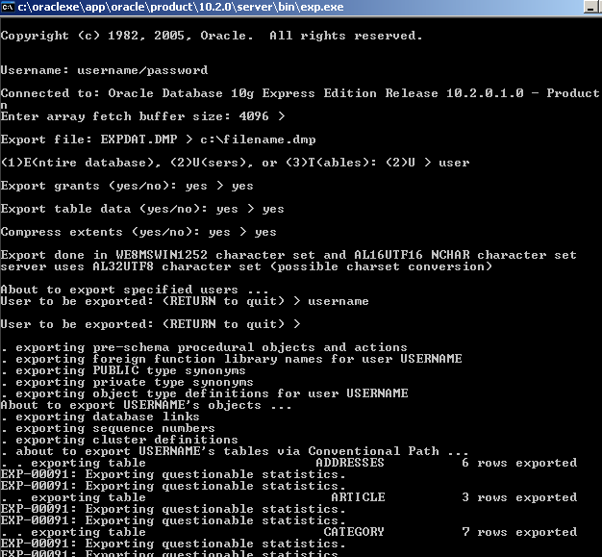

WINDOW CLOSED AUTOMATICALLY.

**IF GETTING ERROR ON CONSOLE:**

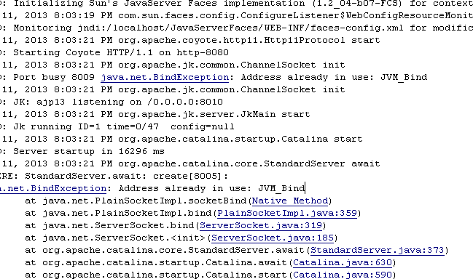

Change Port Number:

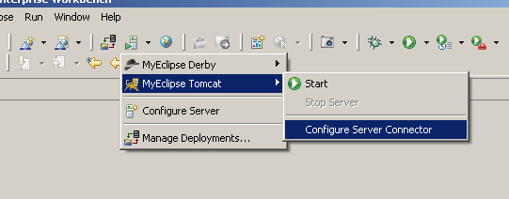

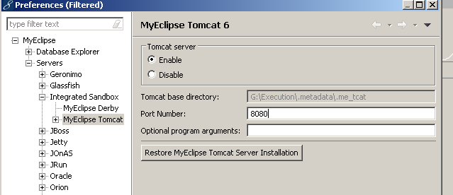

**CHANGE PORT NUMBER:**

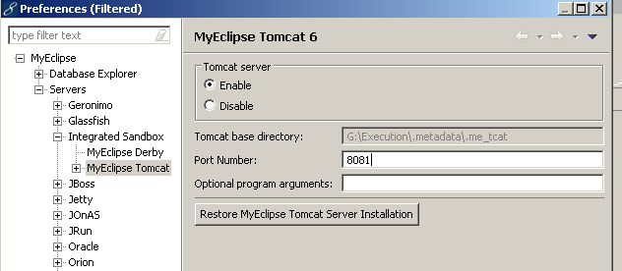

RE RUN PROJECT :

